Hello All,

I would like to add some step to guiding of Hai.

* First, we close ASCET and ATT tool if they are opening and grant Admin right.
* Then, searching for Test Realtime Target Deployment in Start menu and run it as administartor

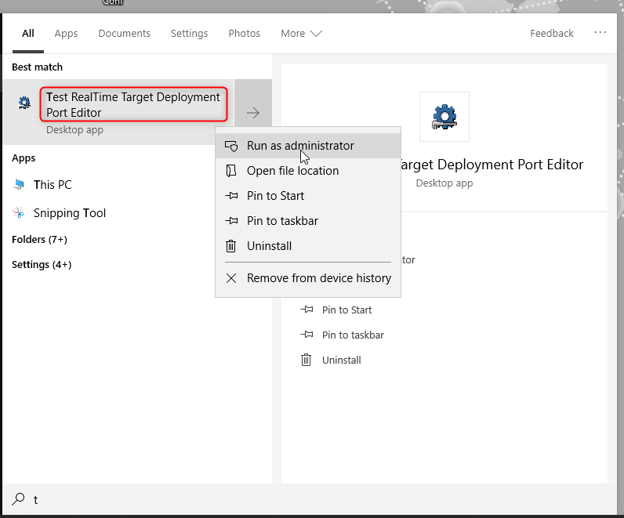

* Next, click File button    →         Open       →      Search cvisual9 in File name        →       Open

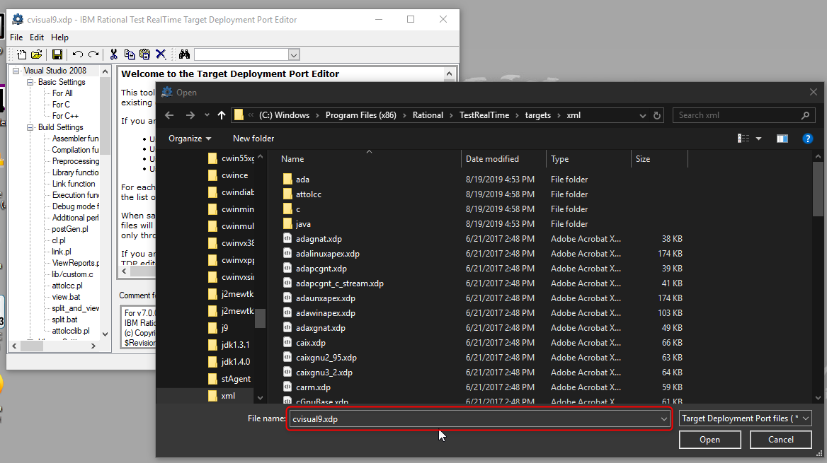

* Finally, click to SAVE button, close the window Test Realtime and run ASCET as administrator

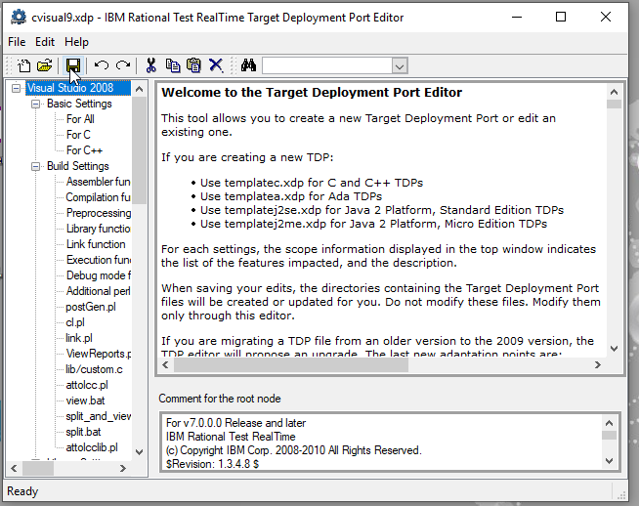

Thank you.

Trân trọng / Best regards,  
  
**Bao Pham Quoc**   
  
Del: CC-AS COEM UT (RBVH/EPS45)  
Robert Bosch Engineering and Business - Solutions Vietnam Company Limited | Unit 11.7, e-town 2 | 364 Cong Hoa, Ward 13 | Tan Binh District | Ho Chi Minh City | VIETNAM | <www.bosch.com.vn>  
Tel. +84 28 3812-9000 | Fax +84 28 38121991 | [Bao.PhamQuoc@vn.bosch.com](mailto:Bao.PhamQuoc@vn.bosch.com)  
  
Managing Directors: Baskaran R (RBVH/GM)   
​

**From:** Tran Hoang Hai (RBVH/EPS45) <[Hai.TranHoang@vn.bosch.com](mailto:Hai.TranHoang@vn.bosch.com)>   
**Sent:** Tuesday, August 25, 2020 10:04 AM  
**To:** Tran Hoang Tuan (RBVH/EPS4 RBVH/EPS44) <[Tuan.TranHoang@vn.bosch.com](mailto:Tuan.TranHoang@vn.bosch.com)>; Pham Huynh Thuy Vi (RBVH/EPS45) <[Vi.PhamHuynhThuy@vn.bosch.com](mailto:Vi.PhamHuynhThuy@vn.bosch.com)>; Pham Quoc Bao (RBVH/EPS45) <[Bao.PhamQuoc@vn.bosch.com](mailto:Bao.PhamQuoc@vn.bosch.com)>; Tran Trung Thinh (RBVH/EPS45) <[Thinh.TranTrung@vn.bosch.com](mailto:Thinh.TranTrung@vn.bosch.com)>; Ung Nho Hoa (RBVH/EPS44) <[Hoa.UngNho@vn.bosch.com](mailto:Hoa.UngNho@vn.bosch.com)>; Lo Minh Thanh (RBVH/EPS44) <[Thanh.LoMinh@vn.bosch.com](mailto:Thanh.LoMinh@vn.bosch.com)>; Dang Thai Hiep (RBVH/EPS44) <[Hiep.DangThai@vn.bosch.com](mailto:Hiep.DangThai@vn.bosch.com)>; Pham Tien Dung (RBVH/EPS44) <[Dung.PhamTien@vn.bosch.com](mailto:Dung.PhamTien@vn.bosch.com)>; Le Minh Hoang (RBVH/EPS44) <[Hoang.LeMinh2@vn.bosch.com](mailto:Hoang.LeMinh2@vn.bosch.com)>; Huynh Thai Duy (RBVH/EPS44) <[Duy.HuynhThai@vn.bosch.com](mailto:Duy.HuynhThai@vn.bosch.com)>; Cao Dang Thang (RBVH/EPS44) <[Thang.CaoDang@vn.bosch.com](mailto:Thang.CaoDang@vn.bosch.com)>; Pham Minh Quyen (RBVH/EPS44) <[Quyen.PhamMinh@vn.bosch.com](mailto:Quyen.PhamMinh@vn.bosch.com)>  
**Cc:** Pham Thi Cam Vien (RBVH/EPS45) <[Vien.PhamThiCam@vn.bosch.com](mailto:Vien.PhamThiCam@vn.bosch.com)>; Nguyen Quang Tien (RBVH/EPS45) <[Tien.NguyenQuang3@vn.bosch.com](mailto:Tien.NguyenQuang3@vn.bosch.com)>  
**Subject:** RE: Fix Issue ATT in ASCET

Hello A.Tuan

Both is OK

But if tool ATT don’t have issue so don’t need to run with administrator

Because when run with administrator the time will longer than run normal

Thanks

Trân trọng / Best regards,  
  
**Hai Tran Hoang**   
  
Del: CC-AS COEM UT (RBVH/EPS45)  
Robert Bosch Engineering and Business - Solutions Vietnam Company Limited | Unit 11.7, e-town 2 | 364 Cong Hoa, Ward 13 | Tan Binh District | Ho Chi Minh City | VIETNAM | <www.bosch.com.vn>  
[Hai.TranHoang@vn.bosch.com](mailto:Hai.TranHoang@vn.bosch.com)  
  
Managing Directors: Baskaran R (RBVH/GM)   
​

**From:** Tran Hoang Tuan (RBVH/EPS4 RBVH/EPS44) <[Tuan.TranHoang@vn.bosch.com](mailto:Tuan.TranHoang@vn.bosch.com)>   
**Sent:** Monday, August 24, 2020 12:33 PM  
**To:** Tran Hoang Hai (RBVH/EPS45) <[Hai.TranHoang@vn.bosch.com](mailto:Hai.TranHoang@vn.bosch.com)>; Pham Huynh Thuy Vi (RBVH/EPS45) <[Vi.PhamHuynhThuy@vn.bosch.com](mailto:Vi.PhamHuynhThuy@vn.bosch.com)>; Pham Quoc Bao (RBVH/EPS45) <[Bao.PhamQuoc@vn.bosch.com](mailto:Bao.PhamQuoc@vn.bosch.com)>; Tran Trung Thinh (RBVH/EPS45) <[Thinh.TranTrung@vn.bosch.com](mailto:Thinh.TranTrung@vn.bosch.com)>; Ung Nho Hoa (RBVH/EPS44) <[Hoa.UngNho@vn.bosch.com](mailto:Hoa.UngNho@vn.bosch.com)>; Lo Minh Thanh (RBVH/EPS44) <[Thanh.LoMinh@vn.bosch.com](mailto:Thanh.LoMinh@vn.bosch.com)>; Dang Thai Hiep (RBVH/EPS44) <[Hiep.DangThai@vn.bosch.com](mailto:Hiep.DangThai@vn.bosch.com)>; Pham Tien Dung (RBVH/EPS44) <[Dung.PhamTien@vn.bosch.com](mailto:Dung.PhamTien@vn.bosch.com)>; Le Minh Hoang (RBVH/EPS44) <[Hoang.LeMinh2@vn.bosch.com](mailto:Hoang.LeMinh2@vn.bosch.com)>; Huynh Thai Duy (RBVH/EPS44) <[Duy.HuynhThai@vn.bosch.com](mailto:Duy.HuynhThai@vn.bosch.com)>; Cao Dang Thang (RBVH/EPS44) <[Thang.CaoDang@vn.bosch.com](mailto:Thang.CaoDang@vn.bosch.com)>; Pham Minh Quyen (RBVH/EPS44) <[Quyen.PhamMinh@vn.bosch.com](mailto:Quyen.PhamMinh@vn.bosch.com)>  
**Cc:** Pham Thi Cam Vien (RBVH/EPS45) <[Vien.PhamThiCam@vn.bosch.com](mailto:Vien.PhamThiCam@vn.bosch.com)>; Nguyen Quang Tien (RBVH/EPS45) <[Tien.NguyenQuang3@vn.bosch.com](mailto:Tien.NguyenQuang3@vn.bosch.com)>  
**Subject:** RE: Fix Issue ATT in ASCET

Hi Hai,

Thanks for sharing the step. Does it mean we need to run ATT with admin right in all cases or only do this when there is issue with tool?

Trân trọng / Best regards,  
  
**Tuan Tran**   
  
(RBVH/EPS4)  
Robert Bosch Engineering and Business - Solutions Vietnam Company Limited | Unit 11.7, e-town 2 | 364 Cong Hoa, Ward 13 | Tan Binh District | Ho Chi Minh City | VIETNAM | <www.bosch.com.vn>  
Tel. +84 28 3812-8212 | Mobile +84 917476063  
  
Managing Directors: Baskaran R (RBVH/GM)   
​

**From:** Tran Hoang Hai (RBVH/EPS45) <[Hai.TranHoang@vn.bosch.com](mailto:Hai.TranHoang@vn.bosch.com)>   
**Sent:** Monday, August 24, 2020 9:28 AM  
**To:** Pham Huynh Thuy Vi (RBVH/EPS45) <[Vi.PhamHuynhThuy@vn.bosch.com](mailto:Vi.PhamHuynhThuy@vn.bosch.com)>; Pham Quoc Bao (RBVH/EPS45) <[Bao.PhamQuoc@vn.bosch.com](mailto:Bao.PhamQuoc@vn.bosch.com)>; Tran Trung Thinh (RBVH/EPS45) <[Thinh.TranTrung@vn.bosch.com](mailto:Thinh.TranTrung@vn.bosch.com)>; Ung Nho Hoa (RBVH/EPS44) <[Hoa.UngNho@vn.bosch.com](mailto:Hoa.UngNho@vn.bosch.com)>; Lo Minh Thanh (RBVH/EPS44) <[Thanh.LoMinh@vn.bosch.com](mailto:Thanh.LoMinh@vn.bosch.com)>; Dang Thai Hiep (RBVH/EPS44) <[Hiep.DangThai@vn.bosch.com](mailto:Hiep.DangThai@vn.bosch.com)>; Pham Tien Dung (RBVH/EPS44) <[Dung.PhamTien@vn.bosch.com](mailto:Dung.PhamTien@vn.bosch.com)>; Le Minh Hoang (RBVH/EPS44) <[Hoang.LeMinh2@vn.bosch.com](mailto:Hoang.LeMinh2@vn.bosch.com)>; Huynh Thai Duy (RBVH/EPS44) <[Duy.HuynhThai@vn.bosch.com](mailto:Duy.HuynhThai@vn.bosch.com)>; Cao Dang Thang (RBVH/EPS44) <[Thang.CaoDang@vn.bosch.com](mailto:Thang.CaoDang@vn.bosch.com)>; Pham Minh Quyen (RBVH/EPS44) <[Quyen.PhamMinh@vn.bosch.com](mailto:Quyen.PhamMinh@vn.bosch.com)>; EXTERNAL Nguyen Tuan Duong (Ban Vien, RBVH/EPS45) <[external.Duong.NguyenTuan@bcn.bosch.com](mailto:external.Duong.NguyenTuan@bcn.bosch.com)>; EXTERNAL Do Phu Loc (Ban Vien, RBVH/EPS45) <[external.Loc.DoPhu@bcn.bosch.com](mailto:external.Loc.DoPhu@bcn.bosch.com)>; EXTERNAL Nguyen Kim Thanh (Ban Vien, RBVH/EPS45) <[external.Thanh.NguyenKim@bcn.bosch.com](mailto:external.Thanh.NguyenKim@bcn.bosch.com)>; EXTERNAL Ly Chung (Ban Vien, RBVH/EPS45) <[external.Chung.Ly@bcn.bosch.com](mailto:external.Chung.Ly@bcn.bosch.com)>; EXTERNAL Nguyen Tran Hoang Huy (Ban Vien Company, RBVH/EPS45) <[external.Huy.NguyenTranHoang@bcn.bosch.com](mailto:external.Huy.NguyenTranHoang@bcn.bosch.com)>; EXTERNAL Nguyen Minh Chuong (Ban Vien Company, RBVH/EPS45) <[external.Chuong.NguyenMinh@bcn.bosch.com](mailto:external.Chuong.NguyenMinh@bcn.bosch.com)>; EXTERNAL Phan The Nam (Ban Vien Company, RBVH/EPS45) <[external.Nam.PhanThe@bcn.bosch.com](mailto:external.Nam.PhanThe@bcn.bosch.com)>; EXTERNAL Nguyen Thanh Phuong (Ban Vien Company, RBVH/EPS44) <[external.Phuong.NguyenThanh@bcn.bosch.com](mailto:external.Phuong.NguyenThanh@bcn.bosch.com)>; EXTERNAL Nguyen Duy Bang (Ban Vien, RBVH/EPS45) <[external.Bang.NguyenDuy2@bcn.bosch.com](mailto:external.Bang.NguyenDuy2@bcn.bosch.com)>  
**Cc:** Tran Hoang Tuan (RBVH/EPS4 RBVH/EPS44) <[Tuan.TranHoang@vn.bosch.com](mailto:Tuan.TranHoang@vn.bosch.com)>; Pham Thi Cam Vien (RBVH/EPS45) <[Vien.PhamThiCam@vn.bosch.com](mailto:Vien.PhamThiCam@vn.bosch.com)>; Nguyen Quang Tien (RBVH/EPS45) <[Tien.NguyenQuang3@vn.bosch.com](mailto:Tien.NguyenQuang3@vn.bosch.com)>  
**Subject:** Fix Issue ATT in ASCET

Hello team,

Please follow step below for run ATT don’t need to reset user

1. Step 1: Raise admin right in ISM

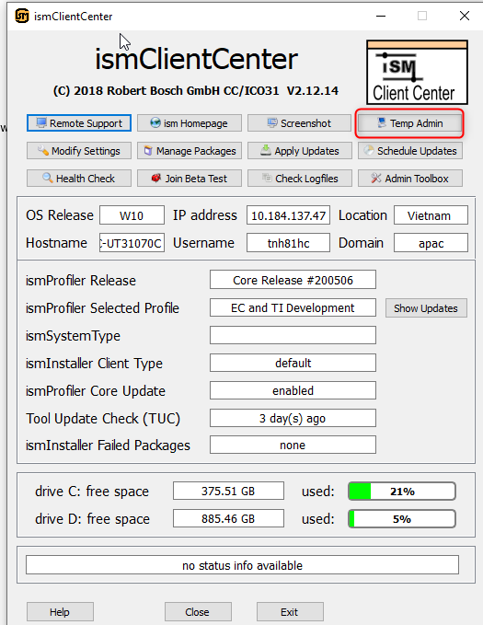

1. Run Ascet with administrator

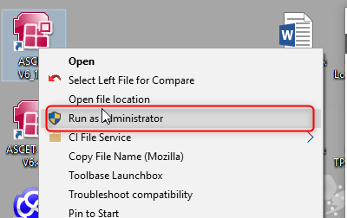

After that Run ATT with normal

Trân trọng / Best regards,  
  
**Hai Tran Hoang**   
  
Del: CC-AS COEM UT (RBVH/EPS45)  
Robert Bosch Engineering and Business - Solutions Vietnam Company Limited | Unit 11.7, e-town 2 | 364 Cong Hoa, Ward 13 | Tan Binh District | Ho Chi Minh City | VIETNAM | <www.bosch.com.vn>  
[Hai.TranHoang@vn.bosch.com](mailto:Hai.TranHoang@vn.bosch.com)  
  
Managing Directors: Baskaran R (RBVH/GM)   
​